
Online Auction Site For Artwork

minor project- A report submitted in partial fulfillment of the requirements for the degree of Bachelor's Degree in Software and System Engineering Information

Prepared by
Lana Alakabani - Yasmin Alhamod

Supervised
by Dr. Kadan aljoumaa

2026 -2027
Abstract
• The art auction industry is evolving with a growing demand for digital platforms that cater to artists, buyers, and art enthusiasts. However, buyers often face significant challenges in discovering and purchasing unique art pieces that match their preferences. On the other hand, artists tend to encounter fewer challenges in selling their artworks and connecting with potential buyers in real-life scenarios.

• To address these challenges, we propose an online auction platform tailored for art pieces. Our solution offers a structured system where sellers can easily list their artworks, buyers can browse and place bids, and art advisors can evaluate the quality and pricing of submissions. The platform also includes robust account management features for various user roles, including visitors, clients, administrators, and shipping companies, ensuring an organized and user-friendly experience.

• By implementing this platform, we aim to enhance the overall user experience, streamline the auction process, and provide a transparent and efficient environment for all stakeholders in the art auction ecosystem.

1.1 Project Overview and Background
The rapid growth of e-commerce and digital technologies has transformed the way people buy and sell products and services. The art industry has also benefited from this transformation, as artists and collectors can now showcase and trade artworks through online platforms instead of relying solely on traditional galleries and physical auctions.
Despite the increasing popularity of online marketplaces, artists and buyers still face challenges in managing artwork sales and participating in auctions efficiently. Many existing platforms do not provide a complete solution that combines artwork management, auction creation, bidding, payment processing, and order tracking within a single system.
This project aims to develop an Online Art Auction System that allows users to upload artworks, create auctions, place bids, and manage transactions through a secure and user-friendly web platform. The system also provides administrative features for reviewing artworks, managing users, and monitoring auction activities.

1.2 Problem Statement and Its Practical and Academic Importance
Traditional art auctions are often limited by geographical location, time constraints, and administrative complexity. Artists may find it difficult to reach potential buyers, while buyers may have limited access to a wide variety of artworks.
In addition, existing solutions may not provide an integrated platform that supports artwork submission, auction management, bidding, payment processing, and delivery tracking in a single environment. This can lead to inefficiencies and a less convenient user experience.
The practical importance of this project lies in providing a centralized platform that simplifies the process of buying and selling artworks online. From an academic perspective, the project offers an opportunity to apply software engineering concepts, web development technologies, database management, and system design principles in a real-world application.

1.3 Project Objectives

Main Objective
To develop a secure and user-friendly Online Art Auction System that enables users to manage artworks, participate in auctions, and complete transactions efficiently through a web-based platform.

Sub-Objectives
- Enable users to register and manage their accounts.
- Allow users to add and manage artwork information and images.
- Provide an approval process for submitted artworks.
- Allow users to create and manage auctions for approved artworks.
- Enable users to place bids on active auctions.
- Provide search and filtering features for artworks.
- Allow users to save artworks to their favorites list.
- Send notifications related to auction activities and artwork status.
- Support online payment processing.
- Manage orders and delivery information.
- Provide reports and statistics for administrators.
- Develop the system using React.js and Laravel within the project timeline.

1.4 Project Scope, Constraints, and Assumptions

Project Scope
The proposed system is a web-based Online Art Auction System. It allows users to register accounts, upload artworks, submit artworks for approval, create auctions, place bids, manage favorite artworks, receive notifications, complete payments, and track orders. The system also provides administrative functions for reviewing artworks, managing users, generating reports, and monitoring auction activities.

Constraints
- Limited project development time due to academic deadlines.
- Limited financial and technical resources available for development.
- Lack of access to large-scale real-world auction data for testing.
- The system will be developed and tested in an academic environment.
- Third-party services such as payment gateways and shipping services may be simulated during development.

Assumptions
- Users have basic computer and internet skills.
- Users have access to a stable internet connection.
- Users provide accurate and complete information when registering and using the system.
- Artwork images uploaded by users are of acceptable quality.
- Administrators will review submitted artworks before they become available for auction.
- Users will follow the platform rules when participating in auctions and bidding activities.

1-5 Project Novelty
The project presents an integrated web-based Online Art Auction System that combines artwork submission, artwork review and approval, auction creation, bidding, payment, and order and delivery management within a single platform. The main contribution of the project is the integration of these functions into a connected workflow that allows users to participate in the buying and selling of artworks through an organized online environment.
The project also integrates modern web development technologies, using React.js to develop the interactive user interface, Laravel to develop the backend and APIs, and MySQL for database management. This integration supports the development of a structured, scalable, and user-friendly platform for online art auctions.
The project does not aim to introduce a new algorithm. Instead, its contribution lies in applying software engineering and modern web development concepts to the field of online art auctions and providing an integrated solution that addresses some of the limitations of traditional art auction processes.

1-6 Research Methodology and Scientific Methods
The thesis adopts a descriptive and analytical research methodology. The descriptive approach is used to study the concept of online art auctions and describe the processes and requirements related to buying and selling artworks through digital platforms. Relevant academic references, previous studies, and related sources are reviewed to provide a theoretical foundation for the project.
The analytical approach is used to analyze the problems and requirements of the proposed platform, identify the roles and needs of different users, and examine the main processes involved in online art auctions. The research also applies scientific methods such as literature review, requirements analysis, comparison of existing approaches, documentation, and evaluation of the developed solution.

1-7 Thesis Organization
This thesis is organized into ten chapters, each addressing a specific aspect of the proposed Online Art Auction System.
Chapter One: General Introduction presents the project background, problem statement, practical and academic importance, objectives, scope, constraints, assumptions, project novelty, and research methodology.
Chapter Two: Project Development and Management Methodology presents the selected development methodology and its justification, project scheduling, risk management, team roles and responsibilities, quality management, project management tools, continuous monitoring and evaluation, and software configuration management.
Chapter Three: Literature Review and Previous Studies reviews relevant literature, previous studies, and existing systems related to online art auctions. It discusses their main features and limitations and identifies the gap addressed by the proposed project.
Chapter Four: System Modeling and Analysis presents the analysis and modeling of the proposed system, including system requirements, actors, use case diagrams, and other relevant analysis models.
Chapter Five: System Architectural Design presents the architectural design of the proposed system, including the overall system architecture, architectural components, their relationships, database architecture, and the interaction between the frontend, backend, APIs, and database.
Chapter Six: Implementation Environment and Tools describes the hardware and software environment used to develop the system. It presents the technologies, programming languages, frameworks, database management system, development environment, version control tools, and other tools used throughout the project.
Chapter Seven: Software Implementation describes the implementation of the proposed system and explains how the designed models and architecture were transformed into a functional application. It presents the main implemented features and interfaces using React.js, Laravel, and MySQL.
Chapter Eight: Testing and Evaluation presents the testing procedures applied to the developed system to verify its functionality, reliability, and compliance with the specified requirements. It includes the test cases, testing methods, and evaluation of the system's main features and performance.
Chapter Nine: Results and Analysis presents the results obtained after implementing and testing the system. The results are analyzed and discussed in relation to the project objectives and requirements, highlighting the main findings, strengths, and limitations.
Chapter Ten: Conclusion and Recommendations summarizes the main findings and conclusions of the thesis, discusses the extent to which the project objectives were achieved, and provides recommendations and suggestions for future improvements and extensions of the system.

Chapter 2
Project Development and Management Methodology

2-1 Development and Project Management Methodology
The Agile methodology was selected for developing and managing the Online Art Auction System due to its flexibility in managing project activities and adapting to changing requirements. Agile focuses on developing the system incrementally through multiple iterations, with continuous testing and improvement.
This methodology helps monitor project progress, identify issues early, and ensure that the project is developed in an organized and systematic manner.

Gantt chart: semester project
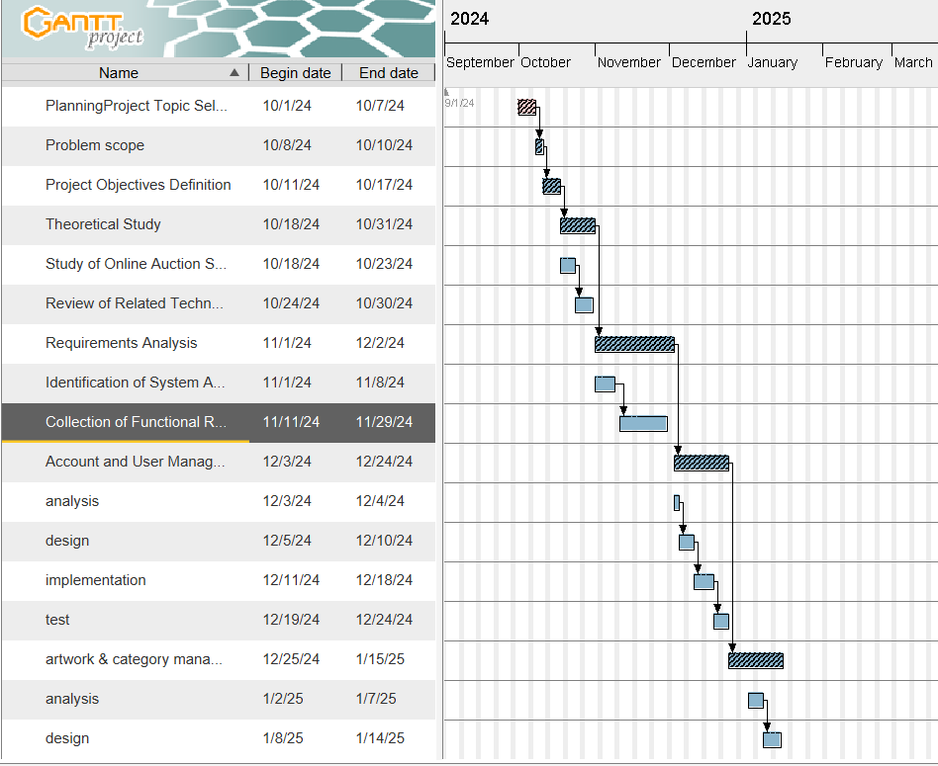
Gantt chart project 1 :
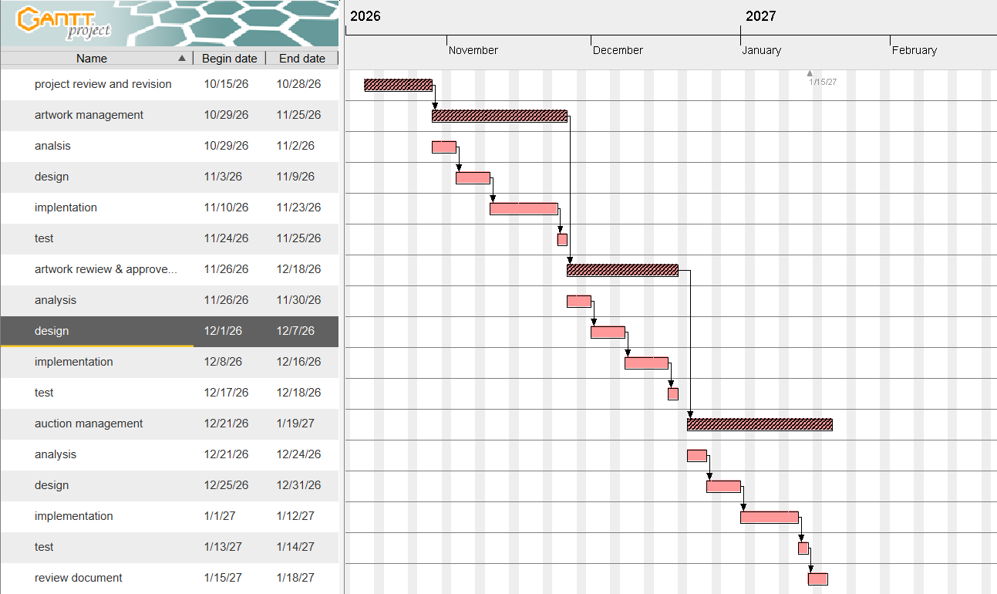

2-3 Risk Management (Risk Register and Mitigation Strategies)

Risk | Probability | Impact | Mitigation Strategy
Delay in implementing software features | Medium | High | Prepare a clear project schedule and prioritize tasks.
Software bugs during development | High | Medium | Perform regular testing and continuous code reviews.
Data or project file loss | Low | High | Create regular backups of the project and database.
Frontend and backend integration issues | Medium | High | Continuously test APIs and integration components.
Changes in project requirements | Medium | Medium | Use the Agile methodology to adapt to requirement changes.
Limited time before project submission | Medium | High | Monitor progress weekly and follow the project schedule.
Development environment or tool issues | Low | Medium | Document configurations and maintain alternative tools when necessary.

Team Members, Roles, and Task Distribution
The project team consists of two students who work collaboratively on the development of the Electronic Art Auction System. Both team members participate in the different stages of the project, including requirements analysis, system design, implementation, testing, and documentation.
Team Member | Role | Responsibilities
Kadan aljomaa | Project manager & Supervisor. | Supervises the project, provides technical and academic guidance, reviews project progress, and ensures that project objectives and academic requirements are met.
Yasmin alhamoud | Analysis, Design, Development (Frontend & Backend), Test. | Participates in requirements analysis, system design, front-end and back-end development, and software testing in collaboration with the other team member.
Lana alakabani | Analysis, Design, Development (Frontend & Backend), Test. | Participates in requirements analysis, database design, front-end and back-end development, and software testing in collaboration with the other team member.
Collaboration Approach
The two student developers share responsibilities throughout the project lifecycle, including planning, requirements analysis, implementation, testing, and documentation. The faculty supervisor oversees the project and provides feedback and recommendations to support progress and ensure the quality of the final system.

Quality Management Plan
The quality of the Electronic Art Auction System will be ensured through the following practices:
- Code Reviews: Both team members will review each other's code to identify errors and improve code quality.
- Static Code Analysis: Laravel Pint will be used to maintain consistent PHP code formatting, while ESLint will help detect potential issues in React code.
- Automated Testing: Postman will be used to test backend functionality, while frontend and integration tests will verify that system components work correctly.
- Acceptance Criteria: Each functional requirement will have clear acceptance criteria to verify that it meets the specified requirements. Critical functions, such as artwork approval, auction creation, and bid validation, will be tested carefully.
- Defect Management: Identified defects will be documented, prioritized, corrected, and retested to ensure system reliability.
- Quality Reviews: At the end of each Agile sprint, completed features will be reviewed and tested, and feedback from the faculty supervisor will be considered.

Project Management Tools
The following tools will be used to support project planning, collaboration, and progress tracking:
Tool | Purpose
Trello | Organizing tasks and tracking progress throughout Agile sprints.
GitHub | Version control, code sharing, and tracking software changes.
Google Drive | Storing and sharing project documents and files.
Google Docs | Collaborative preparation and editing of project documentation.
These tools are suitable for a small development team and will help organize tasks, facilitate collaboration, and maintain project documentation.

Monitoring and Evaluation Mechanisms
- Weekly Meetings: Review progress, discuss challenges, and plan upcoming tasks.
- Supervisor Reviews: Receive feedback and verify alignment with project objectives.
- Sprint Reviews: Evaluate completed features against requirements and acceptance criteria.
- Task Tracking: Monitor task progress and identify delays using Trello.
- Corrective Actions: Address issues and adjust priorities when necessary.

Chapter 3
Literature Review and Theoretical Studies

Related Research on Online Auction Systems:
1. Art Auction Price Prediction (2021)
The study used machine learning techniques to predict art auction prices. It developed models to improve price estimation accuracy, but did not focus on developing an integrated platform for managing auctions and bids.

Korean Management Review
2. Biased Auctioneers: Art Price Estimation (2023)
The study explored the use of neural networks to estimate artwork prices and compare automated estimates with expert valuations. However, it did not focus on managing sales and bidding processes within a complete electronic system.

Wiley Online Library
+1
3. Artwork Price Prediction Using XGBoost (2024)
The study proposed a two-stage model to improve artwork price prediction based on price categories and artwork characteristics. However, it focused on price prediction rather than managing the entire auction process.

Kyoungok Kim, Jong Baek Kim, 2024
4. Predicting Art Auction Results (2024)
The study compared several machine learning and deep learning models for predicting auction results. However, it did not aim to develop an integrated system for managing users, auctions, and bids.

MDPI
5. Smart Contracts for Transparent Online Auctions (2025)
The study used blockchain technology and smart contracts to improve bidding transparency and trust in auction results. However, it focused mainly on technical transparency rather than the complete functionality of an artwork auction platform.

ScienceDirect
6. Fraud Detection and Prevention in Online Auctions (2026)
The study addressed fraud and fake bidding in online auctions. It provides insights into security requirements for auction platforms, but does not cover all the functions required to manage art auctions.

Paradigm

General Conclusion
Previous studies have focused on specific aspects of online auctions, such as price prediction, bidding transparency, and fraud detection. Therefore, our project aims to develop an integrated electronic auction platform for artworks that supports user management, artwork management, auction creation, bidding, and winner selection, with the possibility of incorporating intelligent features in the future.

Modern Technologies and Frameworks in the Field
Modern online auction systems rely on web development frameworks, database management systems, and security technologies to provide efficient, reliable, and user-friendly services.
- Laravel: A PHP framework used to develop the backend, manage business logic, handle authentication, and build secure APIs.
- React: A JavaScript library used to build interactive user interfaces, display artworks, and update auction information dynamically.
- RESTful APIs: Enable communication between the frontend and backend, allowing users to interact with auctions, submit bids, and manage their accounts.
- Database Management Systems: Technologies such as MySQL are used to store user accounts, artwork details, auction information, bids, and transaction records.
- Real-Time Technologies: WebSockets and Laravel Reverb can support real-time updates for bids, auction status, and countdown timers.
- Cybersecurity Technologies: Authentication, authorization, input validation, and encryption help protect user accounts and prevent unauthorized access.
- Artificial Intelligence and Machine Learning: These technologies can be integrated in the future to estimate artwork prices, analyze auction data, and identify suspicious bidding patterns.
These technologies provide a suitable foundation for developing a secure and scalable online art auction platform. Laravel and React form the core development technologies, while additional tools can be introduced according to the project's requirements.

Comparative analysis of current systems and products:
This section presents a comparative analysis of existing online art platforms, focusing on Catawiki and Saatchi Art. The analysis examines their main features, technologies, strengths, and weaknesses to identify opportunities for improvement and guide the development of the proposed Electronic Art Auction System.
Features | Catawiki | Saatchi Art | Proposed System
Artwork Display | Available | Available | Available
Artist Account Management | Available | Available | Available
Online Art Auctions | Available | Not a core feature | Planned
Real-Time Bidding | Available in auctions | Not a core feature | Planned
Real-Time Price Updates | Auction-based | Not a core feature | Planned
Direct Artist-Buyer Communication | To be verified | To be verified | Planned
Auction Management | Available | Not a core feature | Planned
Winner Determination | Available | Not applicable to its main sales model | Planned

Research Gap and Proposed Innovation
Based on the analysis of previous studies and existing platforms, including Catawiki and Saatchi Art, an opportunity has been identified to develop a specialized electronic auction system for artworks. Existing platforms offer different approaches to online art trading, creating an opportunity to integrate essential auction functionalities into a single platform tailored to the needs of artists and bidders.
The proposed system aims to integrate real-time bidding and price updates, artist account and artwork management, direct communication between artists and buyers, and auction management with automatic winner determination. The main innovation lies in combining these functionalities within a unified platform dedicated to online art auctions, with the goal of improving usability, interaction, and auction management.

Theoretical Framework and Related Studies
The proposed Electronic Art Auction System is based on established software engineering principles and web development technologies. The main concepts supporting the system include RESTful architecture, client-server architecture, relational database modeling, authentication and authorization, and auction management rules.
RESTful architecture is used to organize communication between the React frontend and the Laravel backend through APIs. The client-server architecture separates the user interface from the server-side business logic, improving system organization and maintainability.
The relational database model supports the structured storage and management of users, artists, artworks, auctions, and bids. Authentication and authorization mechanisms help protect user accounts and ensure that each user can access only the functions permitted by their role.
Furthermore, the system applies predefined auction rules to validate bids, update auction prices, and determine the winner when an auction ends. Real-time communication technologies may also be used to deliver bidding updates promptly to participating users.
These concepts provide the theoretical and technical foundation for developing a structured, secure, and maintainable electronic auction platform specifically designed for artworks.

Modern and Future Trends in the Field
Modern online art auction systems increasingly use artificial intelligence for artwork recommendations and price estimation, real-time technologies for updating bids, blockchain for transaction transparency, and cybersecurity mechanisms to protect users. Future developments may include smarter recommendation systems, automated artwork valuation, and improved verification of artwork ownership. These technologies could enhance the security, transparency, and efficiency of online art auctions.

Feasibility Study

Technical Feasibility
The system is technically feasible using Laravel, React, and MySQL. These technologies support the main functions, including user management, artwork listings, auction management, and bidding. Development and testing can be performed using an existing computer and available tools.

Financial Feasibility
The project has low initial costs because it uses open-source technologies and free development tools. Development will take place locally using existing equipment. Hosting and domain registration may be required when the system is deployed online.

Operational Feasibility
The system aims to provide an easy-to-use platform for visitors, users, artists, and administrators. It simplifies artwork browsing, bidding, artwork management, and auction supervision.

Schedule Feasibility
The project can be developed in stages according to the graduation project timeline. Requirements analysis, design, implementation, testing, and documentation will be planned to support timely completion.

Requirements Elicitation Workshops
Requirements were identified through the analysis of existing online art platforms, such as Catawiki and Saatchi Art, and the study of the needs of the system's main users. The analysis focused on user management, artwork listings, real-time bidding, auction management, and winner determination.
Tools Used: Online platform review, comparative analysis, and requirements documentation.
Results Summary: The analysis helped identify the main functional requirements and user roles for the proposed Electronic Art Auction System. The findings were used to define the system's initial requirements.

4-2. Stakeholders Identification
The main stakeholders of the Electronic Art Auction System are identified according to their roles and interests in the system.

Stakeholder | Role and Interest
Visitors | Browse artworks and view available auctions.
Users | Upload and manage artworks, participate in auctions, and place bids on other users' artworks.
Administrators | Manage users, artworks, and auction activities.
System Developers | Develop, test, and maintain the system.

4-3. Functional Requirements
The following functional requirements define the main services and operations that the Electronic Art Auction System must provide.

A. User Account Management
FR1: The system shall allow visitors to register a new account.
FR2: The system shall allow registered users to log in using valid credentials.
FR3: The system shall allow registered users to log out securely.
FR4: The system shall allow users to reset their passwords.
FR5: The system shall allow users to view and update their profile information.
FR6: The system shall allow users to change their passwords.

B. Artwork Management
FR7: The system shall allow users to add new artworks.
FR8: The system shall allow users to edit their own artworks.
FR9: The system shall allow users to delete their own artworks when permitted.
FR10: The system shall allow users to upload images of their artworks.
FR11: The system shall allow users to submit artworks for administrative review.
FR12: The system shall allow users to view the review status of their submitted artworks.
FR13: The system shall allow administrators to review submitted artworks.
FR14: The system shall allow administrators to approve submitted artworks.
FR15: The system shall allow administrators to reject submitted artworks.

C. Auction Management
FR16: The system shall allow users to create auctions for their approved artworks.
FR17: The system shall allow users to specify the starting price of an auction.
FR18: The system shall allow users to provide an auction description.
FR19: The system shall display detailed information about each auction.
FR20: The system shall allow users to specify the auction start date and time.
FR21: The system shall allow users to specify the auction end date and time.
FR22: The system shall allow users to edit auction schedules when permitted.
FR23: The system shall display upcoming auctions to users.
FR24: The system shall automatically activate auctions at their scheduled start times.
FR25: The system shall automatically close auctions at their scheduled end times.

D. Bidding Management
FR26: The system shall allow registered users to place bids on active auctions.
FR27: The system shall prevent users from placing bids on their own artworks.
FR28: The system shall validate bids according to the auction rules and current highest bid.
FR29: The system shall update the current highest bid when a valid higher bid is placed.
FR30: The system shall display the bidding history of each auction.
FR31: The system shall allow users to view their own bidding history.
FR32: The system shall allow users to view their active and completed auctions.
FR33: The system shall automatically determine the winning bidder when an auction closes, according to the auction rules.

E. Artwork Discovery and User Interaction
FR34: The system shall allow users to browse available artworks.
FR35: The system shall allow users to search for artworks by relevant information, such as title or artist.
FR36: The system shall allow users to filter artworks by available categories and other relevant criteria.
FR37: The system shall allow users to view artwork details, including its description, images, artist, and auction information.
FR38: The system shall allow users to add artworks to their favorites list.
FR39: The system shall allow users to follow artists on the platform.
FR40: The system shall allow users to communicate directly with other users regarding artworks.

F. Notifications and Transactions
FR41: The system shall notify users about relevant auction events, such as new bids, auction completion, and winning results.
FR42: The system shall allow users to view their notifications.
FR43: The system shall allow the winning bidder to access the payment process for a completed auction.
FR44: The system shall allow users to view their purchase history.
FR45: The system shall allow users to view their sales history.
FR46: The system shall allow users to view order details related to completed purchases.
FR47: The system shall generate an invoice for a completed transaction when applicable.

G. Administrative Management
FR48: The system shall allow administrators to log in using authorized credentials.
FR49: The system shall allow administrators to view, manage, and monitor user accounts.
FR50: The system shall allow administrators to manage artwork categories.
FR51: The system shall allow administrators to monitor auction activities and bidding operations.
FR52: The system shall allow administrators to manage payment and order records.
FR53: The system shall allow administrators to view system reports and statistical summaries.
FR54: The system shall allow administrators to manage platform notifications when necessary.
FR55: The system shall maintain relevant records of important administrative activities for auditing purposes.

